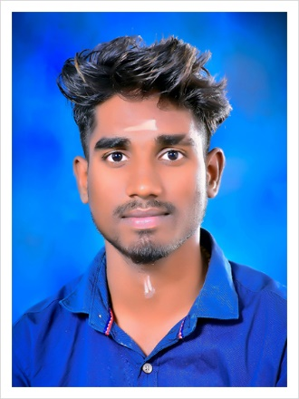**BALAMURUGAN.B**

B.Sc Computer Science,

Department of CS,

Thiruvalluvar Arts And Science,

Kurinjipadi.

# CAREER OBJECTIVE:

Seeking a challenging and rewading opportunity in company which is inline with my academic backround which effectively utilizes my analytical and technical skills

# ACADEMIC QUALIFICATIONS:

|  |  |  |  |  |
| --- | --- | --- | --- | --- |
| QUALIFICALION | INSTITUTE | university/board | YEAR OF PASSING | PERCENTAGE |
| B Sc Com  Science | Thiruvalluvar Arts And Science College,Kurinjipadi. | Annamalai university | 2021 | 73.9 |
| SSLC | Gove.High.Sec School,Theerthanagiri. | State Board | 2019 | 82.5 |
| HSC | Gove.High School,Theerthanagiri | State Board | 2015 | 80 |

# PERSONAL SKILLS

* Good Communication Skill
* Quick learning And Writing

# Personal profile:

NAME : B.BALAMURUGAN

FATHER NAME : V.BALARAMAN

D.O.B : 20.08.2004

GENDER : MALE

RELIGION : HINDU

NATIONALITY : INDIAN

MARITAL STATUS : UNMARRIED

LANGUAGES KNOWN : TAMIL AND ENGLISH

ADDRESS : No:135,kamarajar nagar,

Sirupalaiyur, Theerthanagiri(Post),

Kurinjipadi-Taluk, Cuddalore-District,

Pincode-608801.

EMAIL ID : bhardikbala@gmail.com

MOBILE NO : 9344291601

# Declaration:

I Here Declare That All The Information Furnished Above Is Correct To The Best Of My Knowledge.

Date: Your Faithfully

Place: (B.BALAMURUGAN)